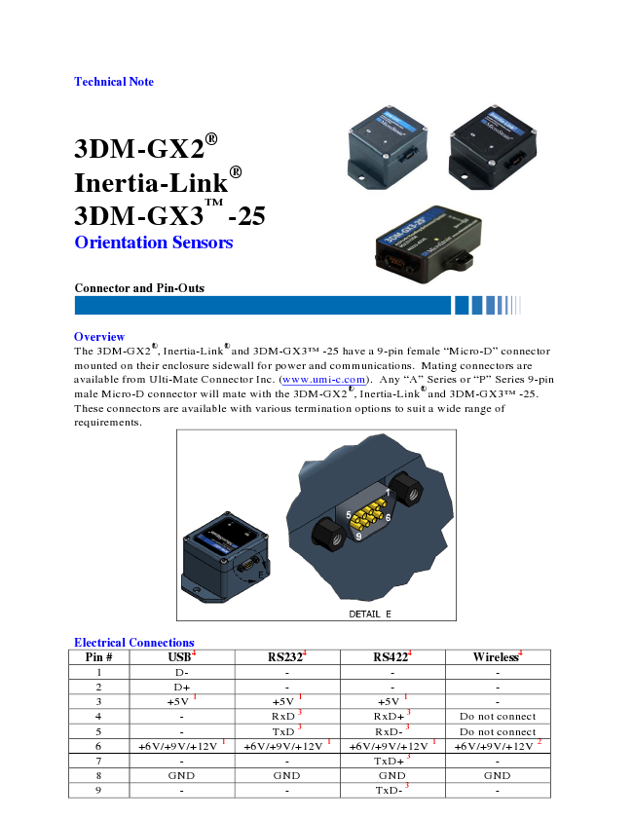
Technical Note
3DM-GX2® Inertia-Link® 3DM-GX3TM -25 Orientation Sensors
Connector and Pin-Outs
Overview The 3DM-GX2®, Inertia-Link® and 3DM-GX3TM -25 have a 9-pin female “Micro-D” connector mounted on their enclosure sidewall for power and communications. Mating connectors are available from Ulti-Mate Connector Inc. (www.umi-c.com). Any “A” Series or “P” Series 9-pin male Micro-D connector will mate with the 3DM-GX2®, Inertia-Link® and 3DM-GX3TM -25. These connectors are available with various termination options to suit a wide range of requirements.
Electrical Connections Pin # USB
4
RS232
4
1 D- - - - 2 D+ - - - 3 +5V 1 +5V 1 +5V 1 - 4 - RxD 3 RxD+ 3 Do not connect 5 - TxD 3 RxD- 3 Do not connect 6 +6V/+9V/+12V 1 +6V/+9V/+12V 1 +6V/+9V/+12V 1 +6V/+9V/+12V 2 7 - - TxD+
3
- 8 GND GND GND GND 9 - - TxD-
3
-
4
RS422
4
Wireless
DETAIL E
Connector and Pin-Outs
Notes 1 Connect either pin 3 or pin 6 (no need to connect both).
Pin 3 voltage allowable range is +4.5V to +5.5V (see Note below). Pin 6 voltage allowable range is +5.2V to +16V (see Note below). Use whichever is more convenient. Leave the unused one unconnected.
2
Wireless products require power on pin 6. Pin 6 voltage allowable range is +5.2V to +16V (see Note below).
3 RxD is the node’s receive pin, and should be connected to the host’s transmit pin. TxD is the node’s transmit pin, and should be connected to the host’s receive pin.
4
Electrical Connections for several communication interface types are shown. Use the connection that is appropriate to the interface on your specific orientation sensor model.
Note: The allowable ranges are stated generally. Please refer to the datasheet of the specific orientation sensor for the exact range of the particular sensor.
Standard Cables MicroStrain offers the following standard cables for use in interfacing to 3DM-GX2®, Inertia- Link
®
and 3DM-GX3TM -25 products:
Part Number Interface 6212-1040 USB Cable 6212-1000 RS-232 Cable 6212-1070 RS-422 Cable 6212-0000 Battery Box (for wireless)
Note: MicroStrain’s standard cables do not provide all wiring patterns as shown in the Electrical Connections table. Please check the mechanical drawing of each cable or with MicroStrain’s support engineers for your specific application.
Custom Cables If you prefer to build your own cables, these parts from Ulti-Mate will aid you:
Part Number Description PR09N05 Male connector, solder cup, plastic housing PR09P05-26E5-4.0 Male connector, 4” 26AWG leads, plastic housing
MicroStrain, Inc. 459 Hurricane Lane, Suite 102 ph: 800-449-3878 Williston, VT 05495 USA fax: 802-863-4093 Copyright © 2010 MicroStrain, Inc. www.microstrain.com support@microstrain.com
Z Micr0Strain'

